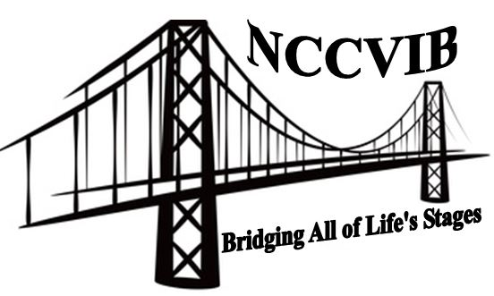
North Carolina Conference on Visual Impairment and Blindness
Bridging All of Life’s Stages
March 3 - 4, 2016
Sheraton Chapel Hill Hotel
NOTE: To write in highlighted form fields click once with mouse and type. To check X boxes, double click on the box and select “checked”.
Name: Title/Position:

Organization:

Preferred Telephone #: E-Mail Address:

----------------------------------------------------------------------------------------------------------------------------------------------------------------------------------------
Registration | Early  Form and payment postmarked by  January 15, 2016 |  | Regular  Form and payment postmarked January 16 – February 15, 2016 |  | On site  Postmarked after February 15, 2016 or received at conference
Presenter (lead presenter only) |  | Fee waived |  | Fee waived |  | Fee waived
Professional |  | $100.00 |  | $125.00 |  | $150.00
University Student or Parent of VI Child |  | $50.00 |  | $75.00 |  | $100.00

If Presenter Registration: Title of Presentation:
Total amount enclosed:
Special sessions and Meals

Yes No Attending Thursday lunch (motivational speaker)?

Yes No Attending Friday lunch (updates from the field)?
Dietary requirements: Vegetarian Meal Gluten-free Other (describe):

Please Indicate Any Special Needs You May Have: Program in Large Print Program in Braille
Sign Language Interpreter Other (please specify)
Please make your check payable to NCAER, w/NCCVIB in the memo line.
Mail this form and your check to: Gina Powell, NC Library for the Blind, 1841 Capital Blvd., Raleigh, NC 27635
Presenters may email their registration forms; all others should send the form with their check via postal mail.
Email: Gina.Powell@ncdcr.gov Subject line: NCCVIB Registration

Thursday lunch and Friday lunch are included with registration fee. Note that we cannot guarantee meals for individuals who register after February 15. Professional development credits are given for attending the vendor session and general session Friday. All participants are expected to download their own conference materials from the website www.ncaer.net. If you cannot download or print handouts in an accessible format, please contact Alan Chase, aachase1@gmail.com

