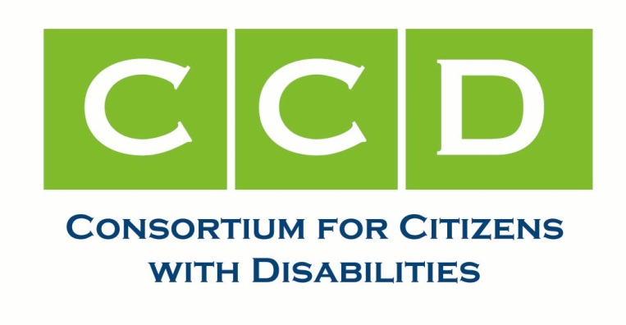

**ACTION NEEDED**

**TELL YOUR SENATORS TO PRESERVE CRITICAL PROTECTIONS**

**FOR STUDENTS WITH DISABILITIES!**

**February 16, 2017**

The U.S. House of Representatives has voted to overturn the Department of Education’s regulation implementing the Every Student Succeeds Act’s (ESSA’s) core requirement that schools be held accountable for the performance of historically marginalized students, including students with disabilities. Congress has never before voted to overturn an education regulation. The Department issued this regulation after the public, including both educators and students and their families, filed over 21,000 comments. The Senate will vote soon on whether to follow the House and overturn the regulation. We ask you to **call your Senators today** to vote **“no”** and protect students with disabilities.

**WHAT YOU NEED TO KNOW:**

The ESSA provides states with flexibility in how they identify schools where students are struggling, how they will hold those schools accountable, and how the states will support those schools. But the ESSA also provides strong “guardrails,” to ensure that schools actually help students, including students with disabilities, learn and achieve proficiency. The ESSA also requires states to issue a “report card” for every public school in the state, so that parents can make informed decisions about where their children will attend school.

Last year the Department of Education issued a regulation strengthening the ESSA, clarifying what the law requires, and specifying timelines for states to develop an accountability plan, including report cards, for schools. In a robust public process, the Department received over 21,000 comments from parents, students, educators, advocates, and others about what the regulation should say. The final regulation gives content to the ESSA’s core requirement that states must ensure that schools take steps to help struggling students, including students with disabilities.

Despite this robust process, on February 7 the House of Representatives overturned the Department’s ESSA accountability regulation. The Senate may vote soon to join the House and overturn the regulation. If the Senate votes “yes” on this bill, H.J. Res. 57, President Trump has said he will sign it, and the Department won’t be able to enforce the ESSA regulation and core protections for students with disabilities will be lost. New Secretary of Education Betsy DeVos has already told states they don’t have to follow the regulation, pending the Senate vote.

**WHAT YOU CAN DO:**

**CALL YOUR SENATOR!** The Senate will vote on whether to overturn the ESSA accountability regulation soon – perhaps later this month. Please call your Senators and ask them to vote “no” on H.J. Res. 57, and to protect the rights of marginalized students, including students with disabilities, to get the help they need to achieve. Call the U.S. Capitol Switchboard at **(202) 224-3121** (the Switchboard line may be busy—you can call back as many times as needed) and ask to be connected to your Senator’s office.

**Tell your Senators to vote NO on the bill to overturn the ESSA accountability regulation, and to protect the rights of students with disabilities!**