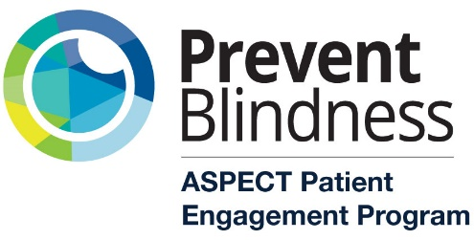

Call for Applications
The application period is now open for all who wish to participate in the ASPECT (Advocacy, Support, Perspective, Empowerment, Communication, and Training) Patient Empowerment Program at Prevent Blindness. We are recruiting individuals with vision impairment or blindness as well as allies (i.e. loved ones, nonprofit representatives, multidisciplinary clinicians, and researchers). The program aims to equip participants with knowledge, skills, and confidence to become advocates for vision and eye health- at the individual, peer-to-peer, community, state, or national levels.
Who is eligible to apply?
Individuals of all ages (including family members of children younger than age 18), with any eye disease/condition, residing anywhere across the nation and globally. Classes are free and held virtually every other week for 8 sessions total, spanning June to September 2022. Specific dates and times to be determined based on the needs of the group. Patient and caregiver participants will receive an honorarium for participation.
ASPECT participants will:
- Partake in eight two-hour educational sessions designed to build advocacy skills and knowledge, communication techniques, and increase awareness of eye conditions other than your own.
- Learn the components of storytelling and become familiar with use of storytelling as an advocacy tool.
- Learn about avenues for patient-engagement and its importance (i.e. research, advisory or advocacy boards, technology, presentations, social media).
- Discover a sense of community through listening to the stories of your peers, sharing, and supporting one another through the challenges and triumphs associated with visual impairment and blindness.
- Build leadership capacity by having the opportunity to co-facilitate sessions and present on various topics to your fellow participants.
- Be invited to join the annual Eyes on Capitol Hill advocacy day and/or the Focus on Eye Health National Summit, as able.

What is the value to participating in ASPECT?
According to graduates of the program:

“I was touched by the stories that were shared about blindness and low vision. Even though we all had different eye conditions and journeys, we all shared something in common, we were all there to better ourselves and the community around us by wanting to educate others who lack an understanding of what it’s like to live with vision loss. Many of us took part in presenting content that challenged our thinking while motivating us to bring this knowledge into the world.”
“The ASPECT program has provided an invaluable account of the varied expertise and nuanced perspectives of patients, providers, and other eyecare stakeholders regarding approach to care and patient needs […] which has already helped me to reimagine my approach to research, as well as my interactions with persons who experience vision loss and other forms of disability. Discourse between ASPECT participants helped to illuminate gaps in the current health paradigm as well as provide insight into potential approaches for bridging these gaps. It is a most excellent initiative that empowers participants to be innovative, inclusive, and circumspect in their approach to eyecare, be they patients, providers, allies, or researchers.”

“ASPECT equipped me with tools to effectively advocate for patients who are participants and beneficiaries of eye care services. These conversations have contributed to shaping my perspective on advocacy and healthcare delivery and the value in patient identified factors to attain best visual health outcomes. I am almost the eye doctor that I have longed to be and grateful for the role Prevent Blindness and ASPECT have played in shaping me into a public health centric optometrist.”
To learn more, visit our website. If you or someone you know is interested in participating, please have them complete a short 2-page application found here: or call Julie Grutzmacher at 312-363-6032 if you are not able to complete the application online.
The deadline to apply is Friday, June 3, 2022.
For additional questions about the program, reach out to Julie Grutzmacher, Director of Patient Advocacy and Population Health Initiatives, at: jgrutzmacher@preventblindness.org

