In collaboration with ICEVI, WBU and other stakeholders, Royal Dutch Visio is spearheading an effort to reach out to young people with visual impairments (blind and low vision) to determine their wishes and concerns related to the future. This letter provides you with information about our proposed survey and explains how you can help us reach as many young people as possible.

How do young people with a visual impairment see their future?
Let’s ask them and let them talk about this subject.
https://youtu.be/cL24hlTbOHE
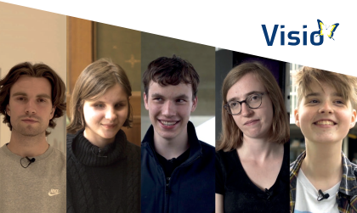
In this video, five young adults in The Netherlands with visual impairments talk about their future dreams (audio is Dutch with English subtitles). Their video was posted on the Project Aspiro website as a resource for others with vision loss and sowed the seeds for further discussions into how young people with visual impairments see their futures. The video was also part of the Vision congress 2022.
The initiators of the survey believe that all young people with visual impairments worldwide have the right to education and participation in society. Everyday parents and concerned adults do as much as possible to ensure success for young people with visual impairments. However, there remain obstacles in education and employment. We would like to know what young people themselves consider these to be.
What we need from you:
- Please link to our survey if you are between the ages of 18 and 30 years old and have a visual impairment using one of the following links:
- Dutch: https://forms.office.com/r/6ejfuvd0qB
- English: https://forms.office.com/r/MsGe3j4HzN
- Spanish: https://forms.office.com/r/CW2PWBkBsX
- French: https://forms.office.com/r/przCfFCzNR
- Arabic: https://forms.office.com/r/aGzAcU5Eha
- If you know anyone between the ages of 18 and 30 years old who has a visual impairment, please forward this letter with the links to the individual.
- If you are an agency or organization representative, teacher, counsellor, or other professional, please disseminate our survey to anyone you know between the ages of 18 and 30 years old who has a visual impairment.

The survey is fully accessible as a Microsoft form and the link to our digital questionnaire, will be active from March 8th until April 14th, 2023. If you have any questions, please contact: Judith Wijnen: judithwijnen@visio.org or Klaske van Zandbergen: klaske.vanzandbergen@student.hu.nl

What we will do to follow up:

- We plan to organize two international meeting days on Wednesday (June 28, 2023) and Thursday (June 29, 2023) based on the results of the survey. The meeting on June 29 will be held physically for those who can be present at the Visio board office in Huizen. Meeting day details with information on how to get to the venue will be sent to anyone who expresses an interest in attending.
- To accommodate international participants and those unable to attend in person, we are offering time slots for digital participants. On 28 June there will be a time slot from 13:00 PM GMT/UTC to 15:00 PM GMT/UTC. On 29 June there will be a time slot from 07:00 AM GMT/UTC to 09:00 AM GMT/UTC.
- The agenda items for these meeting days will emerge from the survey. At the end of the questionnaire, it is possible to register for your preferred meeting day. The meetings will be held in English.
- A report of the research and the meeting day will be sent to anyone who is interested.

